1. **Experiment:** Flow Cytometric Analysis of NK Cell Activity
2. **Time:** 2025.05.10-2025.05.29
3. **Member:** Xudong Tang, Yang Jin, Binxuan Zhang, Kaiqing Zhang, Xuantong Liu
4. **Materials:** Flow cytometer, CD107a-APC, CD56-PE, CD69-FITC, Ice-cold PBS Staining buffer, Brefeldin A, 4% paraformaldehyde (PFA), 0.1% Triton X-100
5. **Method:**
6. **Cell preparation:**

NK cells pre-activated by B34G35R, B51G35R, and B51G9 are collected from previously proliferated cells, with 0.5-1 × 10⁶ PBMCs or 0.1-0.5 × 10⁶ purified cells per condition.

The cells are resuspended in pre-warmed (37 °C) culture medium at appropriate density.

1. **Surface staining:**
2. CD69 expression was analyzed in all twenty groups demonstrating cytotoxic activity using flow cytometry.
3. Post-cytotoxicity assay, cells in each well were washed once with 1 mL of ice-cold PBS and resuspended in 100 μL staining buffer.
4. Cells were stained with CD69-FITC (BioLegend, 310904), CD56-PE (BioLegend, 362508), CD107a-APC (BioLegend, 328620) to identify NK cells.
5. Activated NK cells were defined as CD56⁺CD69⁺, while total NK cells were CD56⁺.
6. CD69-FITC (1:100), CD107a-APC and CD56-PE (1:50) were added. Samples were incubated at 4 °C for 30 min protected from light. Control tubes were prepared.
7. 200 μL ice-cold Flow Staining Buffer was added. The tube was centrifuged at 300 × g for 5 min. And the supernatant was aspirated completely.
8. The cells are resuspended with 100-200 μL Fixation Buffer, and incubated at room temperature for 15-30 min.
9. 200 μL Flow Staining Buffer was added and the tube was centrifuged at 300 × g for 5 min. The supernatant was aspirated completely.
10. **Acquisition:**
11. The suspension was transferred to flow cytometry sample tubes.
12. Analysis Strategy:

Gate to exclude doublets (using FSC-A vs FSC-H).

Gate to exclude dead cells (using a viability dye).

Identify the target cell population (NK cells: CD3⁻ CD56⁺).

Analyze the expression levels of CD69 and CD107a on the surface of NK cells.

1. **Result:**

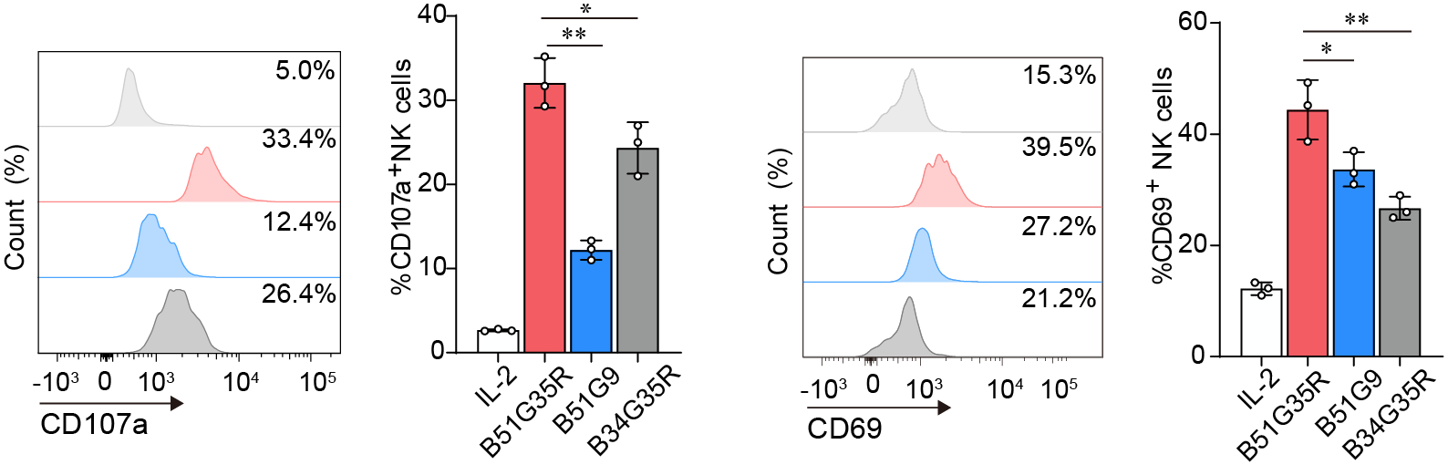

**Figure.1** CD107a and CD69 expression were analyzed in effector cells after stimulated by IL-2 and its mimics. Data are representative of at least three independent experiments (\*\**P* < 0.01, \**P* < 0.05).